1. SignUp

Action: Signup with incomplete fields

Steps:Click on navigation bar

Expected results: "Please fill out this field" message pops up.

Pass/Fail: Pass

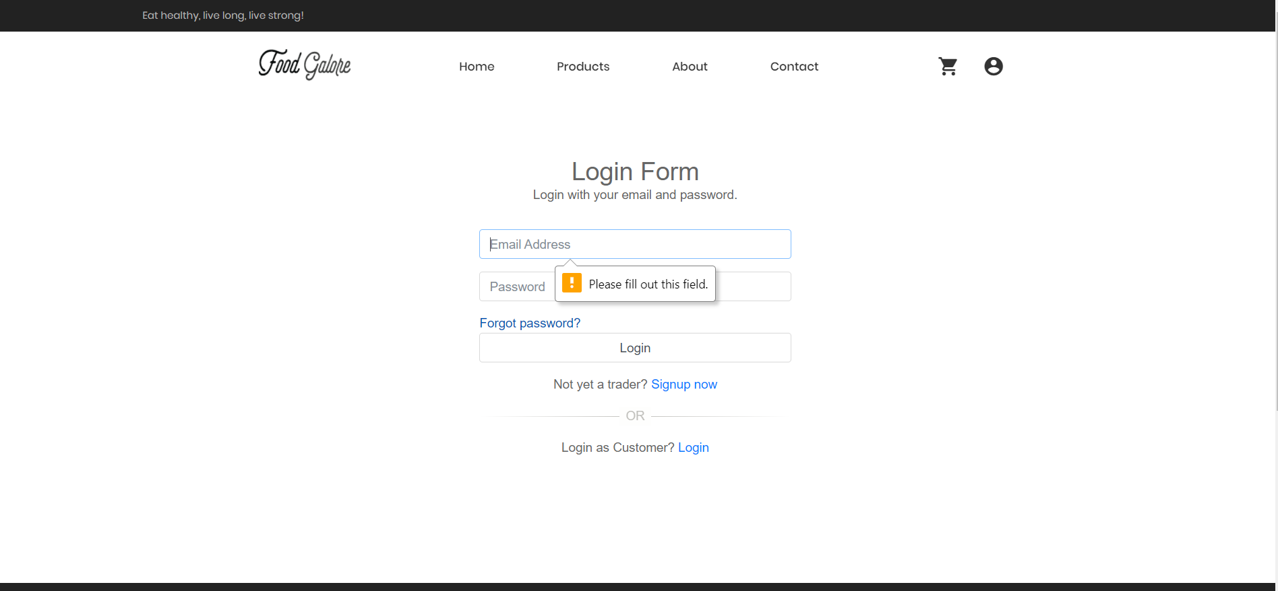

Action:Signup with email.

Steps: After signing up, a verification code is sent.

Expected results: Verification code is sent to the email.

Pass/Fail:Pass

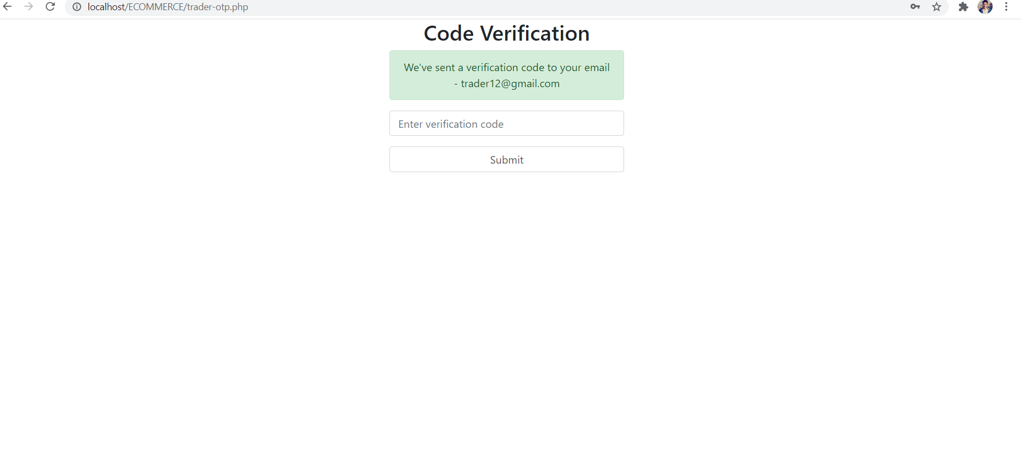

Action:Signup with wrong password or Email.

Steps: If incorrect password or Email is inserted.

Expected Results:Error message is displayed.

Pass/Fail: Pass

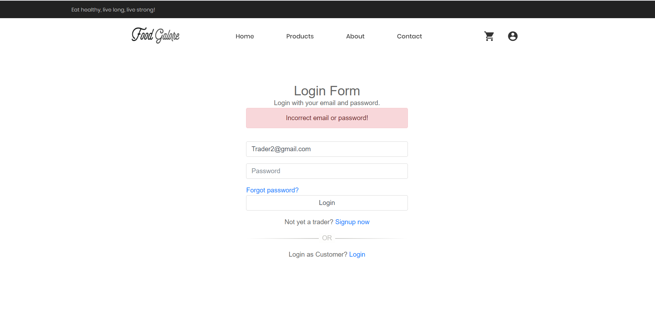

Action:Signup with wrong password in Re-type password.

Steps: After inserting password which does not match.

Expected Results:"Password doesn’t match" message is displayed.

Pass/Fail: Pass

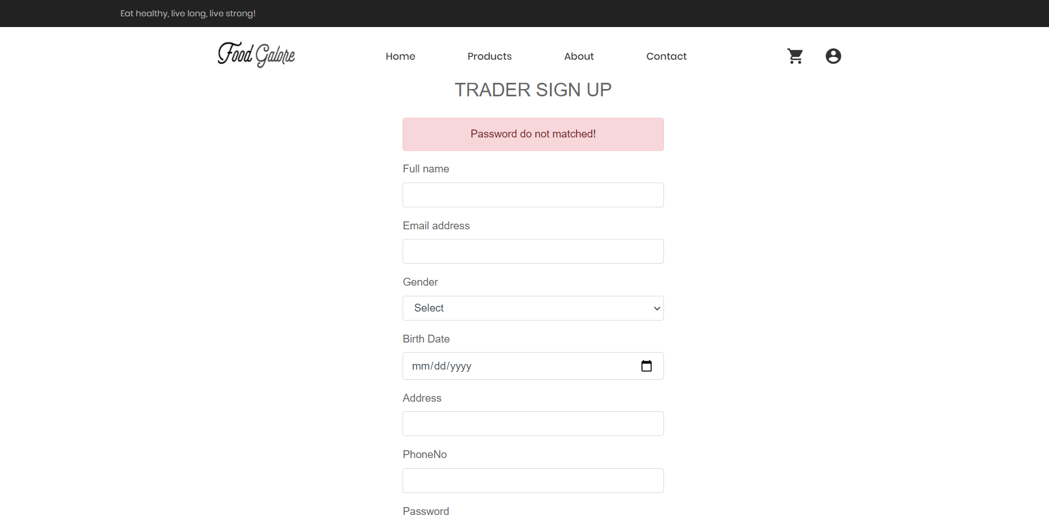

Action:Signup with all correct details.

Steps: After inserting all the correct details

Expected Results:You are signed up.

Pass/Fail: Pass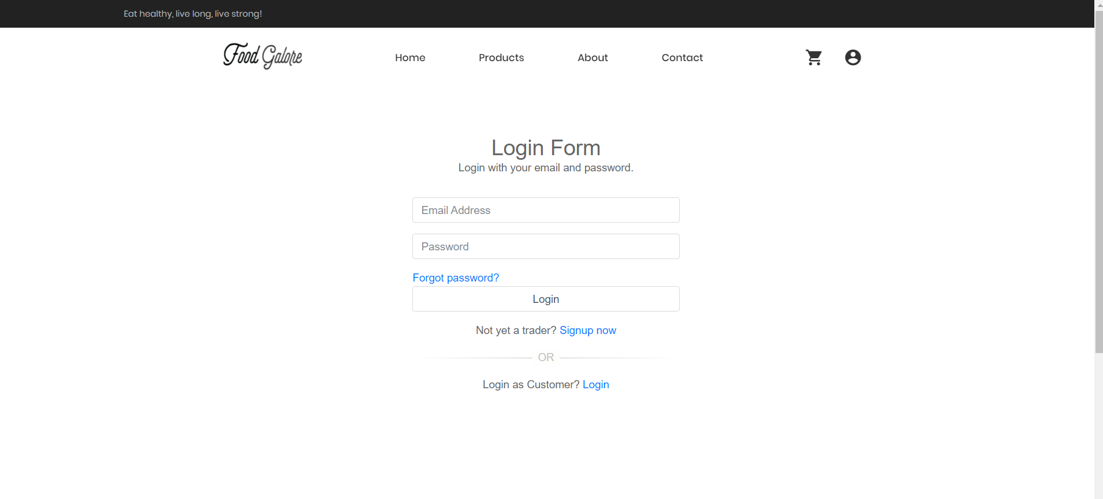

1. Login

Action:Login with correct username and password.

Steps: Click on login button.

Expected Results:You are logged in as a trader.

Pass/Fail:Pass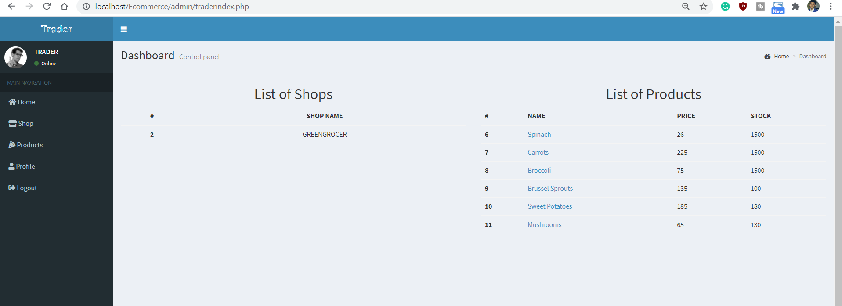

Action:Click in forgot password action.

Steps:Click on the forgot password button.

Expected Results:You are required to type your email and a verification code will be sent to that mail.

Pass/Fail:Pass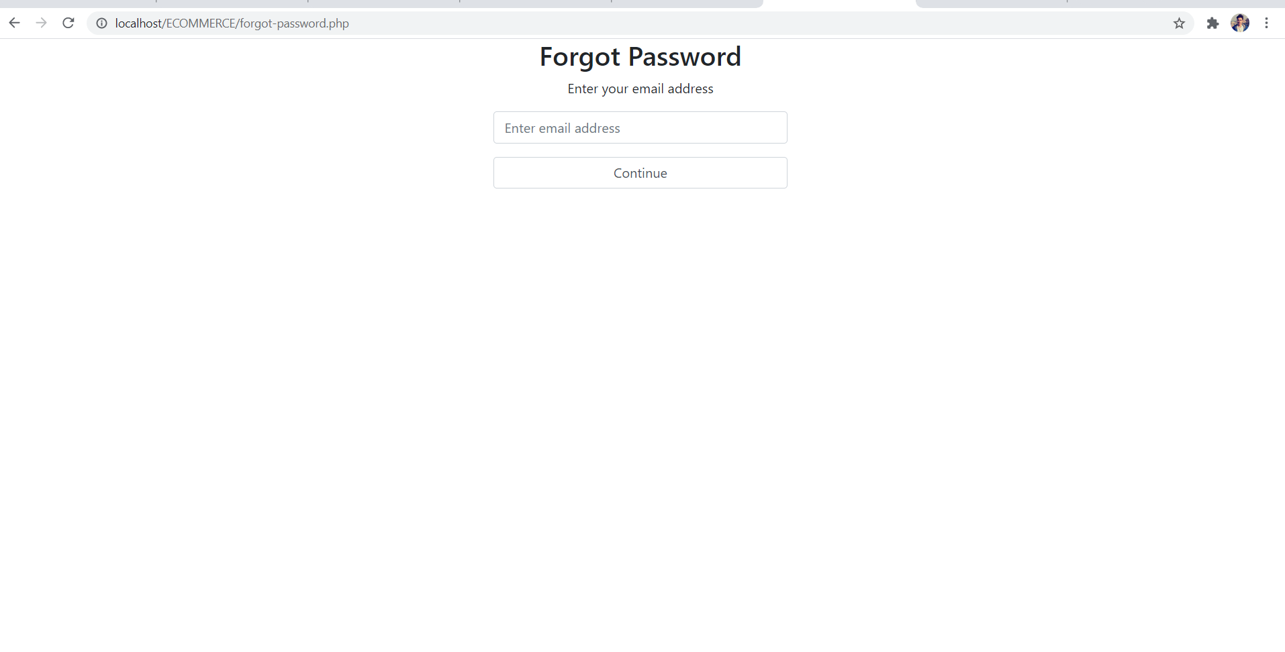

1. Personal details

Action:Personal details page.

Steps: Click on the “Account settings” icon.

Expected Results:You will be taken to the profile section.

Pass/Fail:Pass

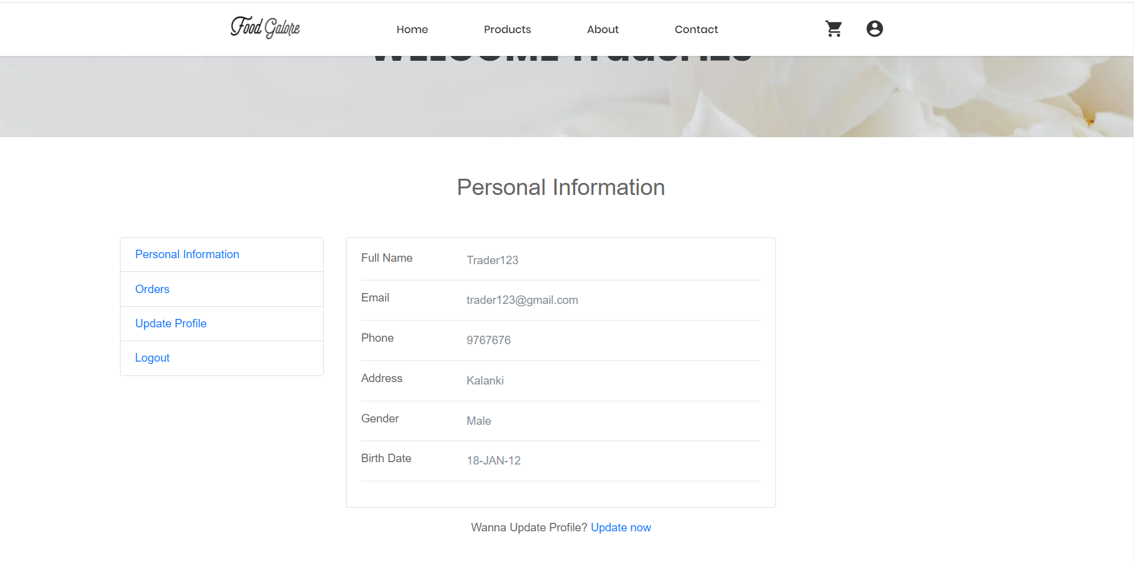

Action:Edit the personal information.

Steps: Once the correct trader login credentials are filled, you will see a page with a dashboard . You can also update your Shop Details, Personal Details as well as Contact Details.

Expected Results:You can change your personal information

Pass/Fail:Pass

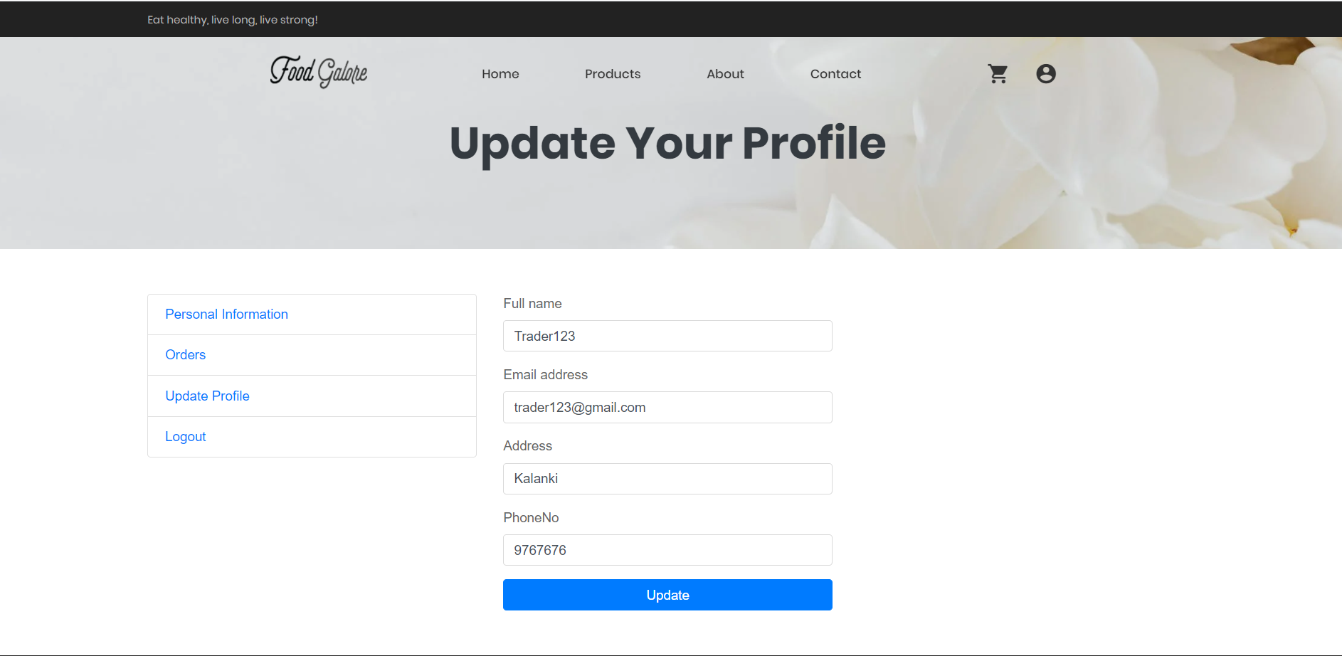

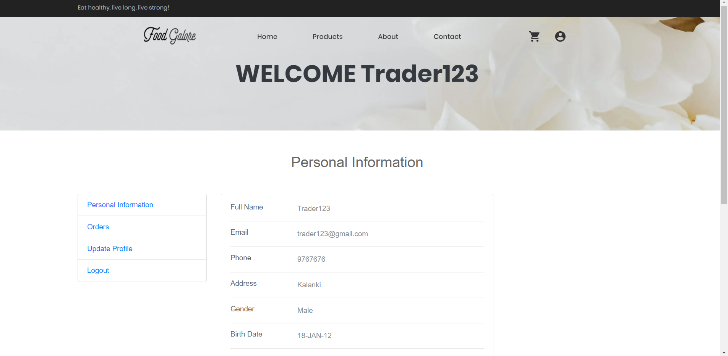

3. Shop

Action:Add shop.

Steps: Click on Shop button.

Expected Results:Traders can add a shop.

Pass/Fail:Pass

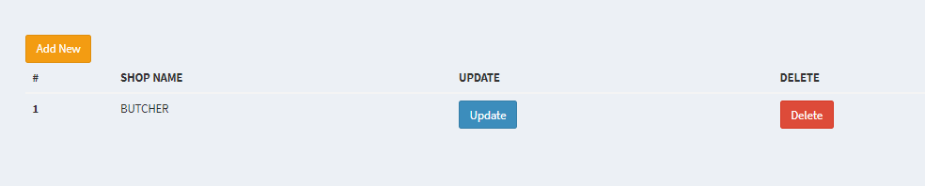

Action: Edit shop.

Steps:1. Enter the shop name and image link of the shop. Traders are only allowed to add two shops.

Expected Results:Redirect to edit shop page.

Pass/Fail: Pass

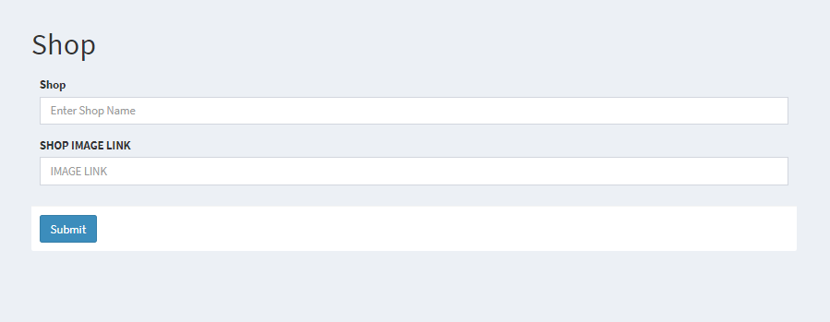

Action: Delete shop.

Steps: Click on Delete shop button

Expected Results:Delete the shop

Pass/Fail: Pass

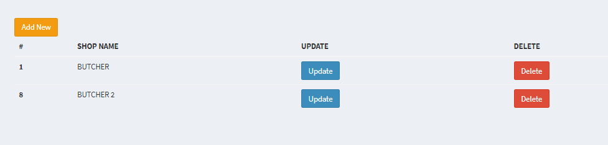

1. Products

Action: Add products page

Steps: Click on Products

Expected Results:added product page is displayed

Pass/Fail: Pass

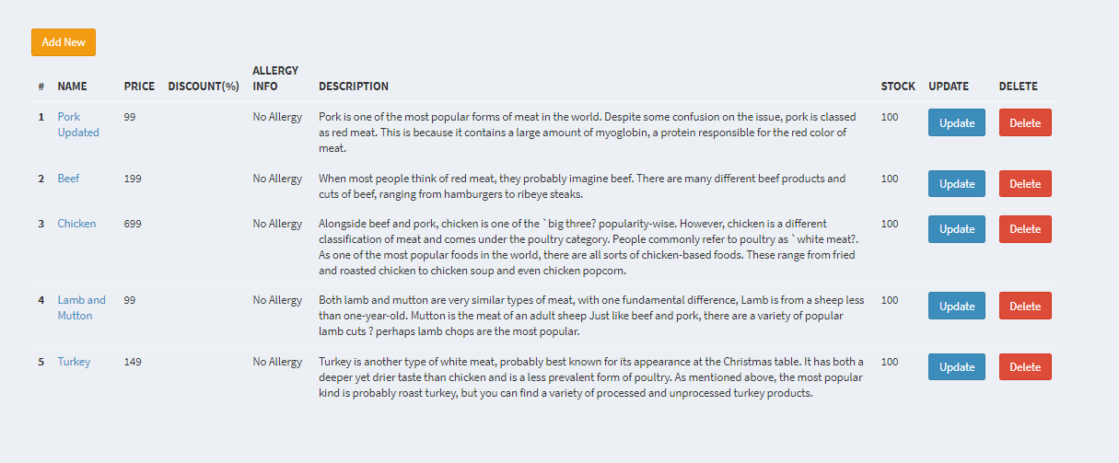

Action:Edit products details

Steps: Enter the product details.

Expected Results:Redirect to product page

Pass/Fail:Pass

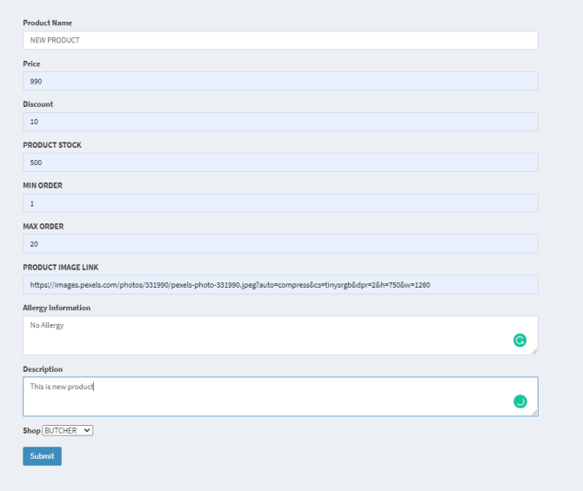

Action:Delete products details

Steps: Click on delete product details button.

Expected Results:Delete the shop

Pass/Fail: Pass



1. Logout

Action:Logout page..

Steps:

Expected Results: Traders can logout of the site.

Pass/Fail:Pass

